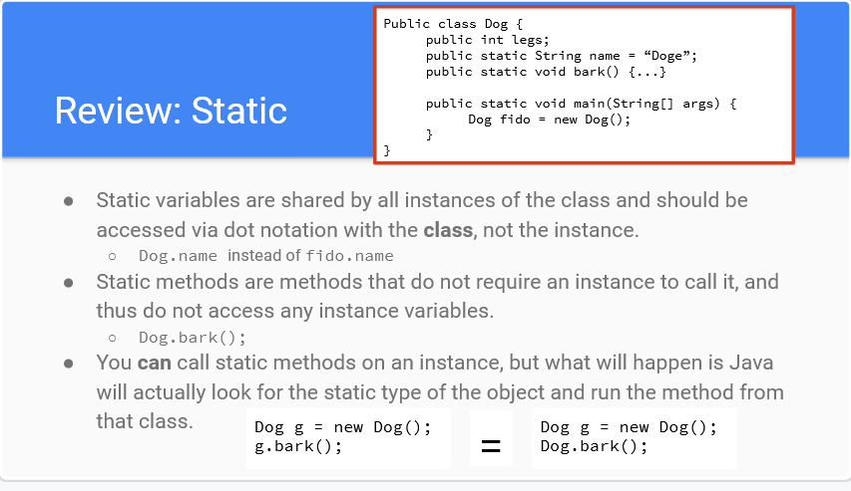

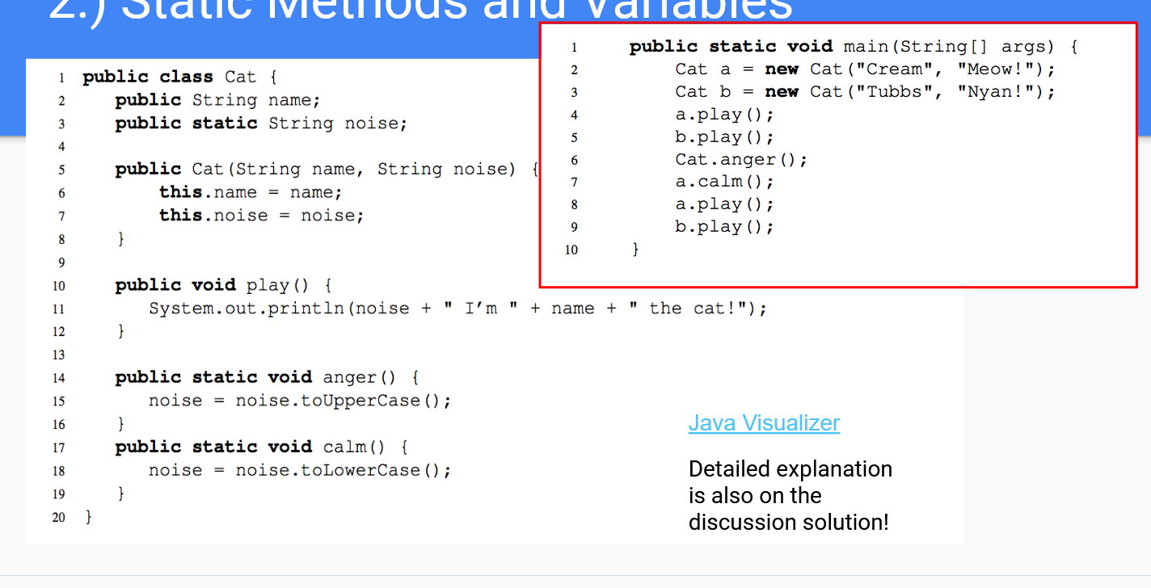

Cat.anger()

a.calm() 根据框住的Notes，calm() is a static method that should be called with a class. When it’s called with an object, Java goes to the object’s class and run the method from that class. 把static variable noise直接变成小写。尽管anger()把noise变成大写。

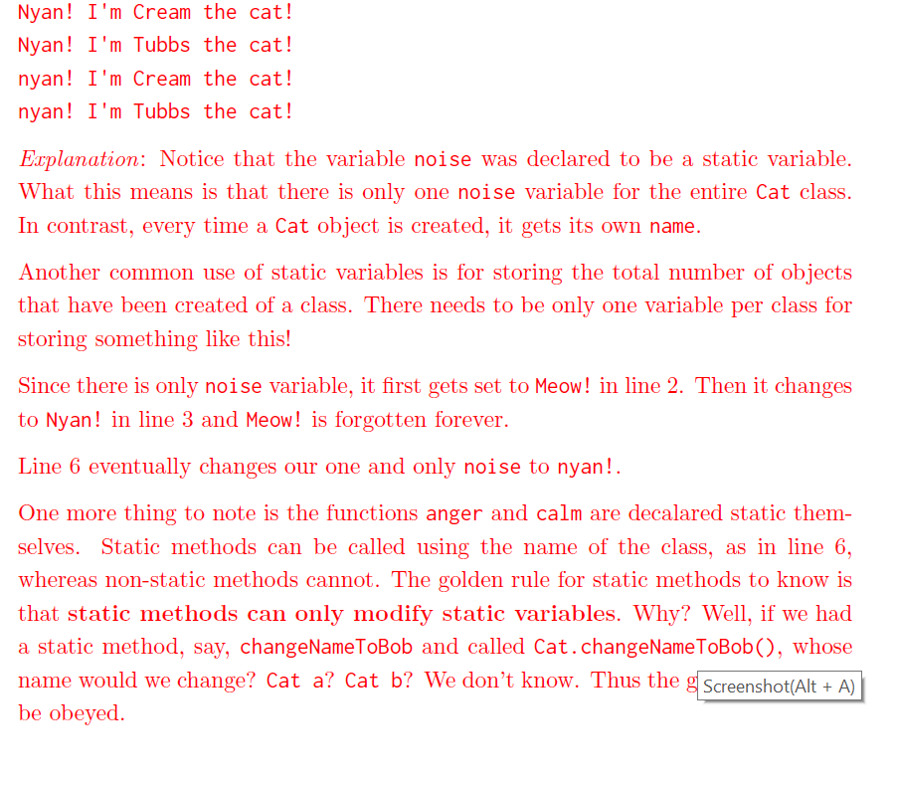

**第二题**

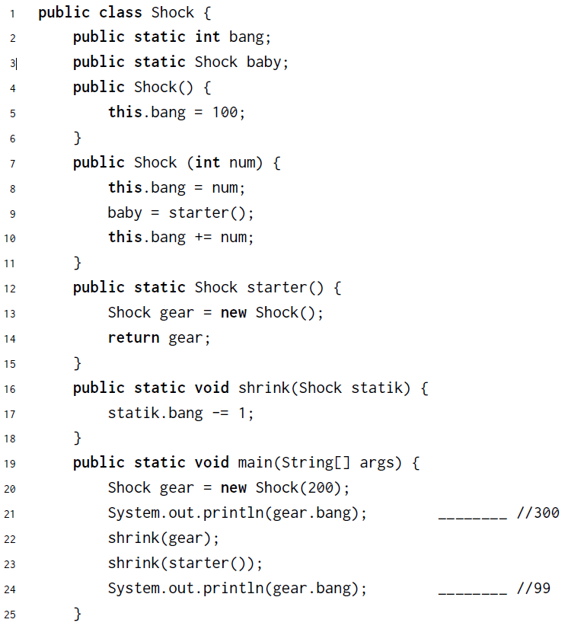

Here’s the step by step breakdown:

1. Static fields of ‘Shock’ class:  
   Shock.bang = 0  
   Shock.baby = null
2. In line 20, a new ‘Shock’ instance is created and assigned to the name ‘gear’. In line 8, ‘Shock’ class’s static variable ‘bang’ is assigned to 200:  
   Shock.bang = 200  
   Shock.baby = null
3. In line 9, a new ‘Shock’ instance is created through starter() and assigned to baby. In starter(), it called Shock() which changed the static variable ‘bang’ from 200 to 100:  
   Shock.bang = 100  
   Shock.baby = Shock instance
4. In line 10, the Shock.bang is updated by adding itself to num, which is 100 + 200 = 300, and  
   Shock.bang = 300  
   Shock.baby = Shock instance
5. In line 22, shrink is called to decrease the ‘Shock’ class’s static variable ‘bang’ by 1. In this example, it creates confusion because it seems that we are calling ‘gear’ instance. Since this is static variable, we’re just using ‘gear’ instance to access the ‘Shock’ class’s static variable, which creates confusion. That’s why this practice is not recommended (See above comment in ‘Static variables’)  
   Shock.bang = 299  
   Shock.baby = Shock instance
6. In line 23, it did two things: one is called starter(), which calls Shock() and set ‘bang’ to 100; two is calling shrink(), which decrease ‘bang’ by 1; So change would look like this:  
   Shock.bang = 100  
   Shock.baby = Shock instance  
   Shock.bang = 99  
   Shock.baby = Shock instance

Reference：http://ouwang.me/2018/09/23/Static-vs-Non-Static-Methods-Variables-in-Java/